M365 Provisioning Tool

Agency Admin and User Guides

Contents

Version 1

References 1

Links Summary 1

Overview 2

Agency Administrator Guides 2

SharePoint Site Template Creation 2

Teams Team Template Creation 2

Groups Template Creation 2

Template Management 2

Approver Group Management 5

User Guides 8

Request Process 8

Approver Guides 12

Approval Request Received via Email 12

View Active Approvals in App 14

# Version

|  |  |  |
| --- | --- | --- |
| Version | Release Data | Notes |
| 1.0 | 10/03/2023 | Initial Version |

# References

|  |  |
| --- | --- |
| Name | Comment |
|  |  |
|  |  |

# Links Summary

|  |  |
| --- | --- |
| Link | URL |
|  |  |

# Overview

# Agency Administrator Guides

## SharePoint Site Template Creation

## Teams Team Template Creation

## Groups Template Creation

* Groups do not have templates files for this provisioning solution, but a record is still required in the Template selection to allow a request to select that request type
* Even though a SharePoint site is provisioned during the Microsoft 365 Group process it is not templated in this request type

## Template Management

* Templates are listed in a pool of template items, they are not assigned to a specific Agency or Department Initially. Approver Templates which are associated with an Agency will list all its associated templates from the pool.

1. Access Approver Groups & Templates Management from home screen button

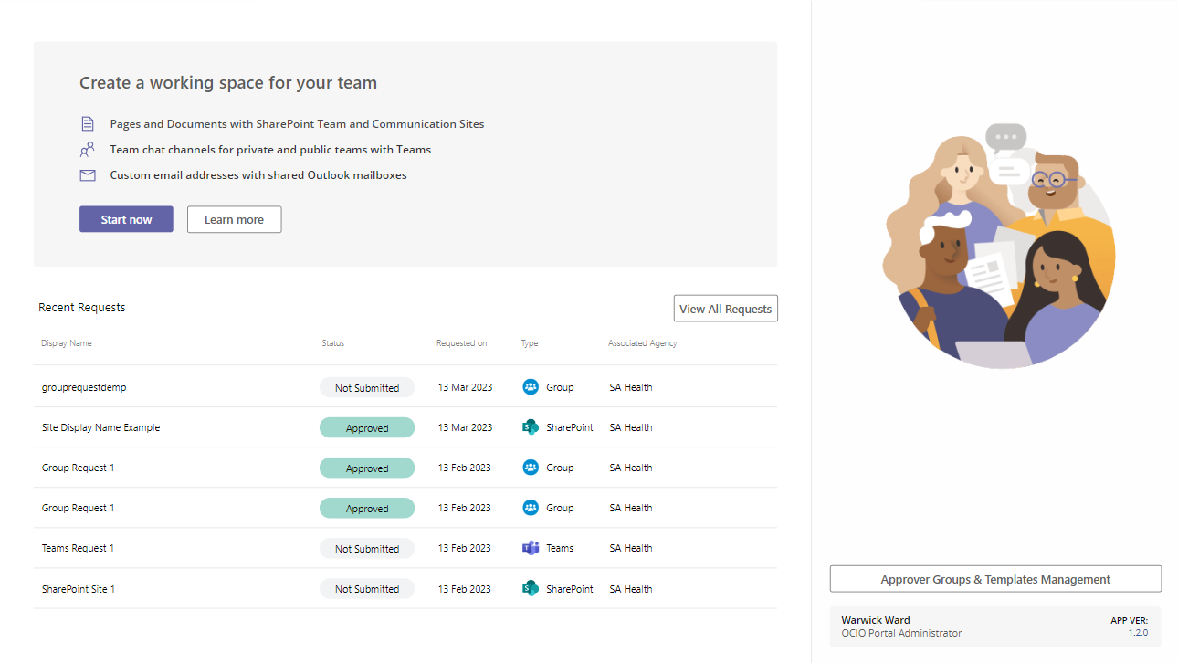

**Existing Templates**

1. View and Edit existing templates from the list

1. Open a template to Edit settings and upload new template file if required

**Create a New Template**

1. Click New Template

1. Enter in details of Template, selecting a template file to upload and associate to record if required

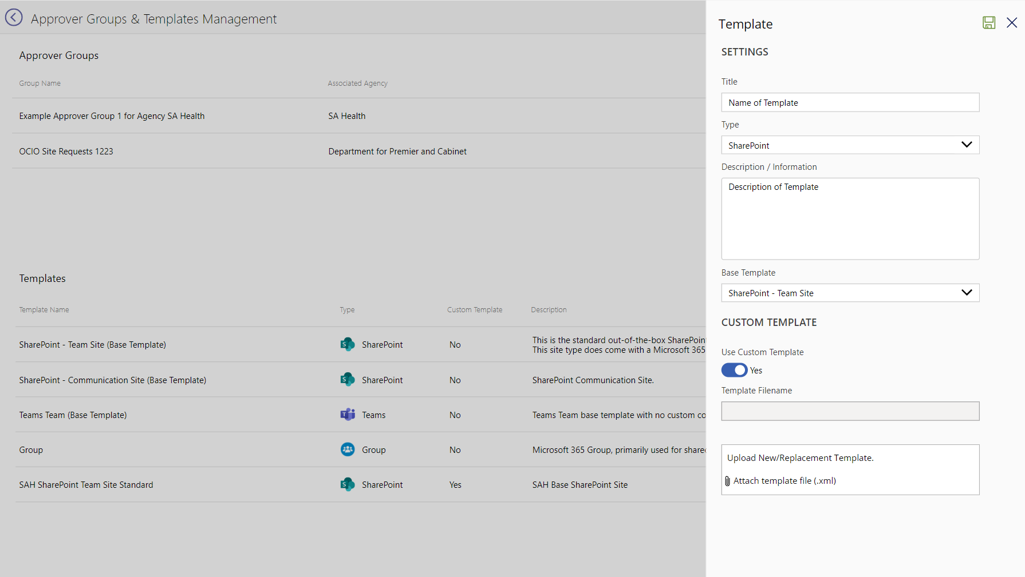

## Approver Group Management

1. Access Approver Groups & Templates Management from home screen button

**Existing Approver Group**

1. Select an existing Approver Group to edit, opening the side panel
2. Edit Settings as required, Saving once finished

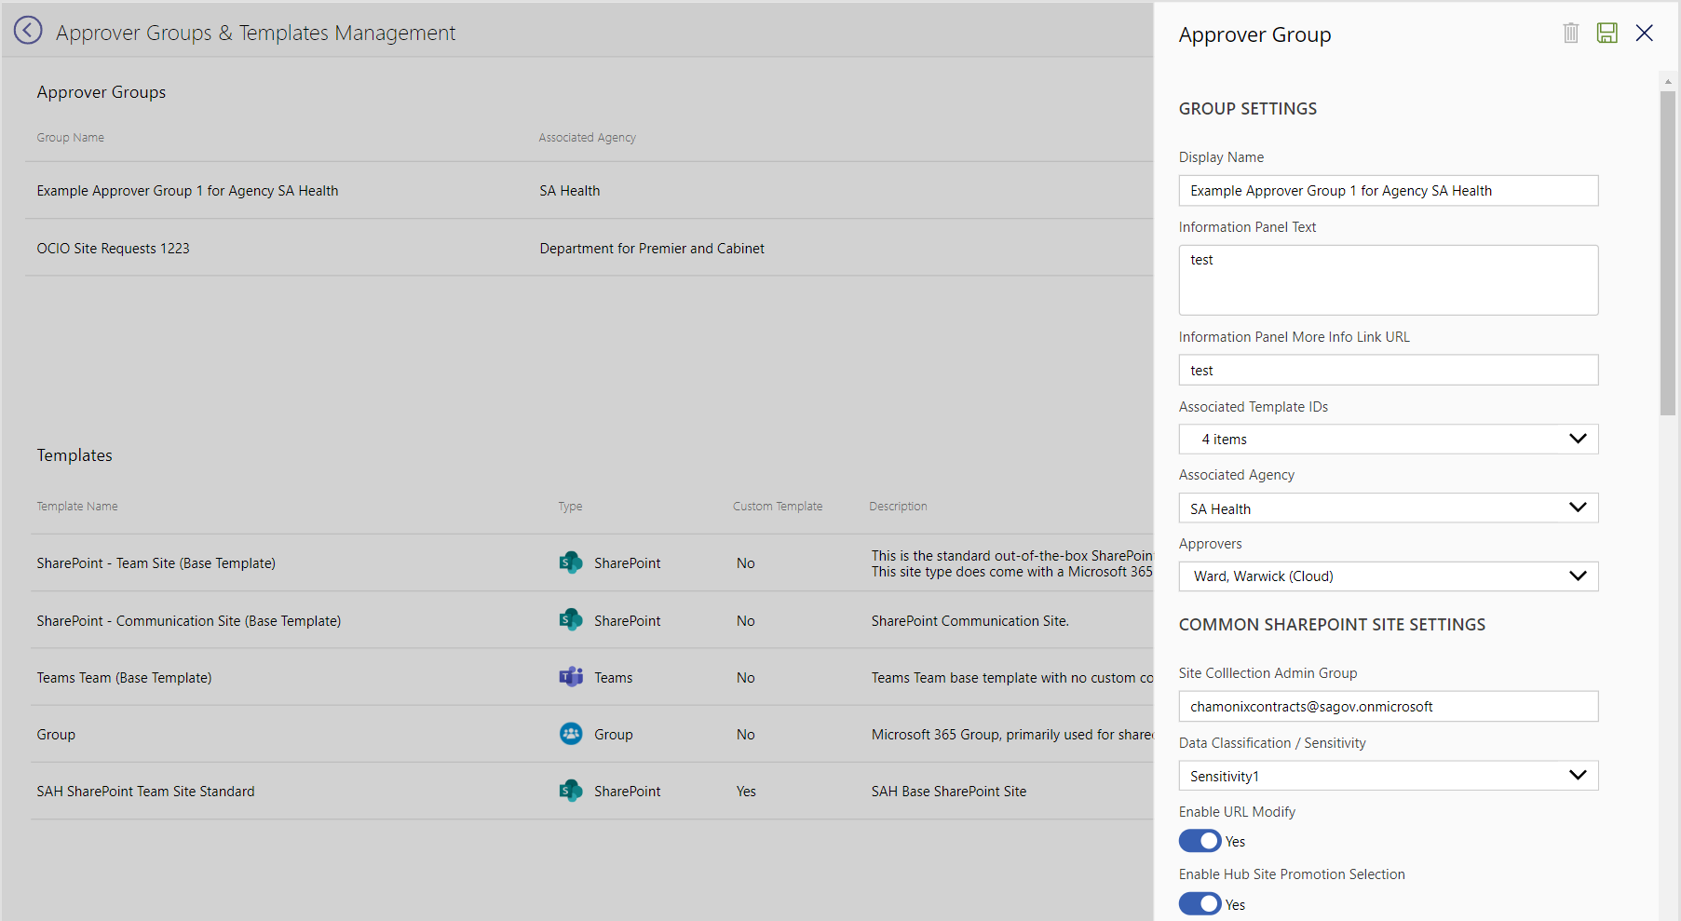

**New Approver Group**

1. Click New Approver Group to start creation process
2. Enter in all details as required in the sections as listed below
   1. Group Settings
   2. Common SharePoint Site Settings (Settings will apply to all template types associated with the group)
   3. Groups Templates (Settings will apply to Groups templates associated with the group)
   4. Teams Templates (Settings will apply to Teams templates associated with the group)
   5. SharePoint Template (Settings will apply to SharePoint templates associated with the group)

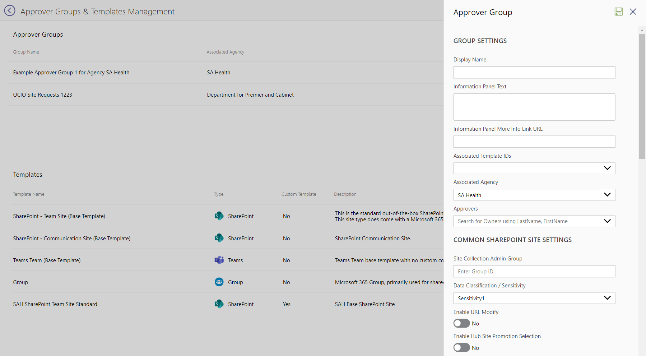

# User Guides

## Request Process

* Users are able to request a new Site, Team or Group following the process detailed below

1. From the App landing screen click State now

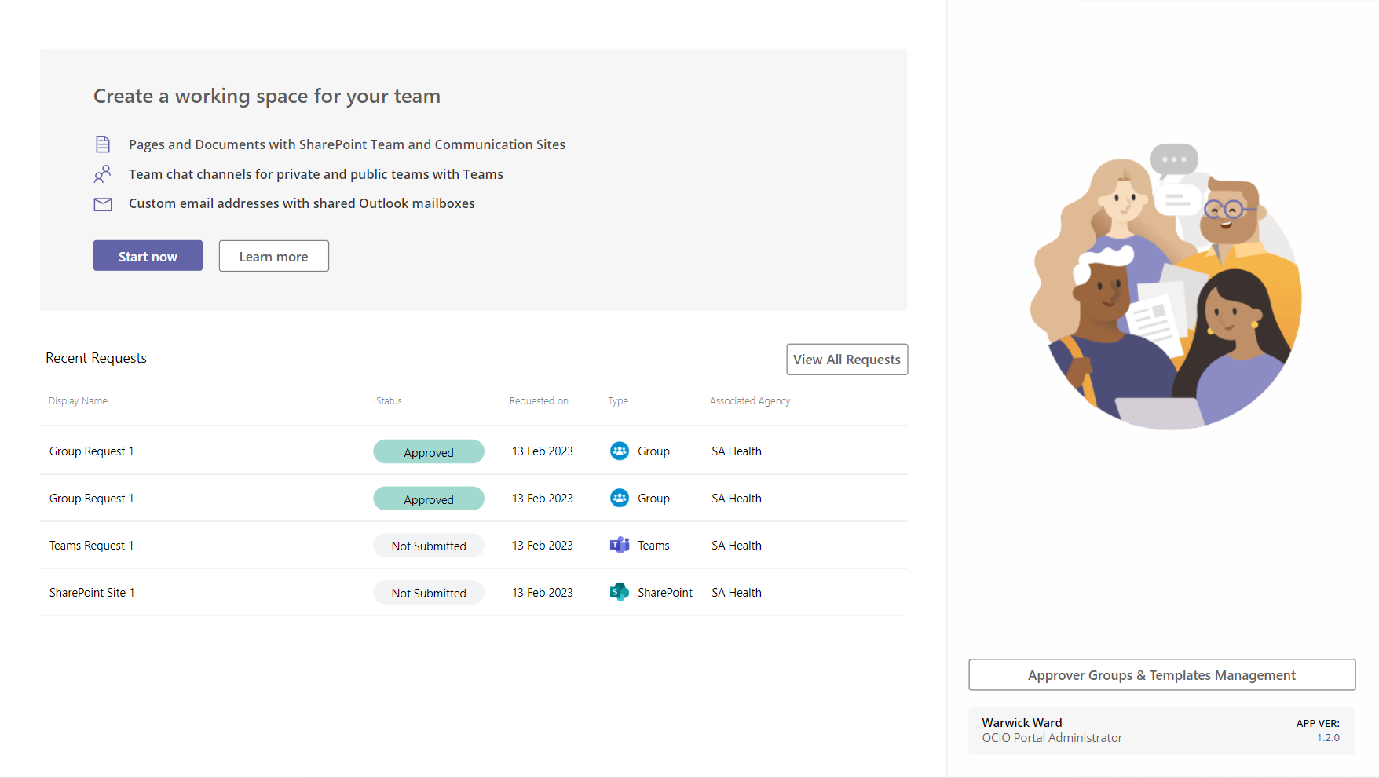

1. Select Approver Group associated to the current user request

1. Select Template required for type of request

1. Enter in all details of the request as required on the screen
   1. Some fields may be locked is determined by the Approver Group settings

Screenshot of SharePoint Site Request Details Screen:

Screenshot of Teams Team Request Details Screen:

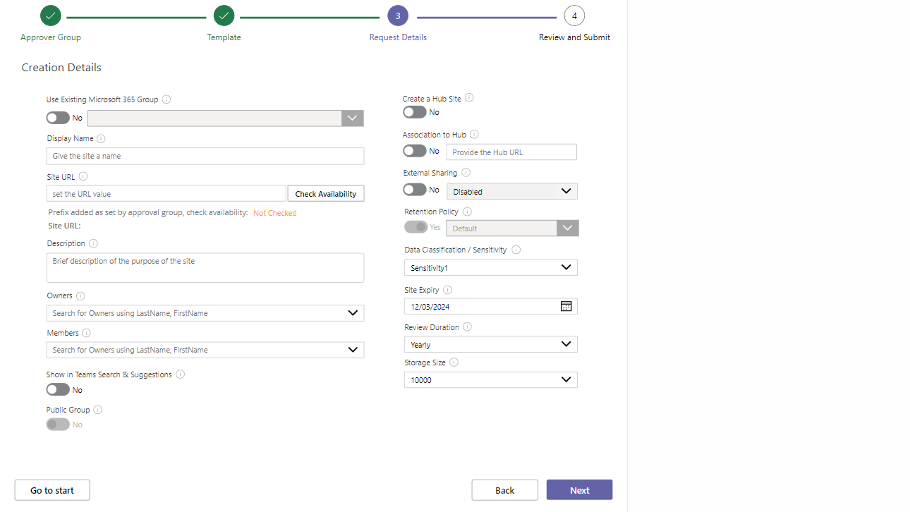

Screenshot of Group Request Details Screen:

1. Review details of request and Submit request

1. Prompt will be show to check status on Request screen

1. View newly created request on Requests screen
   1. Request will initially show with the status of “Submitted”, changing to “Pending” once approval process has started shortly after

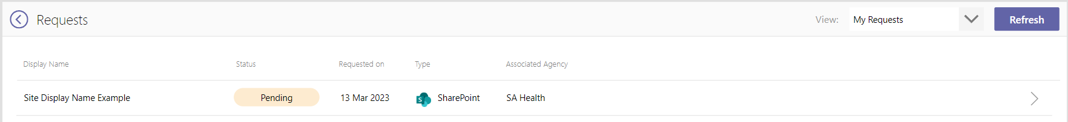

# Approver Guides

## Approval Request Received via Email

* One way an Approver will be notified of a pending request is via email
* Approvers can respond directly via the email buttons or via accessing the app
* If a request has multiple Approvers assigned, its first to respond

1. Email received by Approver (Example shown below)

1. A quick response (Not viewing whole record within the app) is possible selecting either the Approved or Rejected button in the email

If an Approver responds to a request that has already been actioned, they will receive the following message upon clicking one of the responses in the email:

## View Active Approvals in App

* Requests assigned to Approved with a “Pending” status are viewable via the App
* There are three views for view approvals in the App
  + My Approvals – Accessible by all users, showing only approvals assigned to current user
  + Agency Approvals – Accessible by Agency Admins, shows all approvals for the current users associated Agency (Show against username on home page)
  + All Approvals - Accessible by OCIO Portal Administrators Only
* Only open or requests in the “Pending” state are show in approval screens.

1. Open All and click on View All Requests button

1. Select View: of required screen

